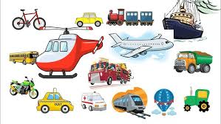
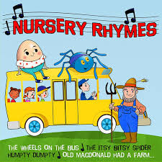
Communication, Language and Literacy | Mathematics
Pupils will be encouraged to develop their communication, indicating their wants and needs, listening and following instructions and maintaining their attention.  Pupils will learn a new phonic sound a week and will be encouraged to write and read / identify this sound in words. They will learn and identify environmental sounds.  The children will begin to read simple words and also look at books and discuss what they can see in the pictures of the story.  Pupils will be encouraged to make marks indifferent sensory ways as well as on paper and put meaning to these marks, as well as independently write their name. | Pupils will learn number songs to help them engage with numbers.  Pupils will be introduced to numbers to 10 (20) and understand the composition of these numbers (number bonds). Pupils will learn about more / less and early addition and subtraction.  Pupils will learn about mathematical concepts of size, weight and shape.  The children will learn about 2D and 3D shapes. Naming them and starting to look at the properties of shapes.

Launchpad - Spring Term
Here is an overview of what your child will be learning this term which we hope you will find useful. We would welcome any comments or questions you might have.

Other Curriculum Areas
Physical Development- Pupils will develop their fine motor skills through threading, dough disco and mark making in a range of media. Pupils will engage in gross motor skills including ball skills, climbing and balancing and riding a tricycle.
Personal, Social & Emotional – Pupils will focus playing alongside others and beginning to share with others.
Understanding the World – Pupils will learn different properties of materials. They will learn about animals and different types of transport.
Expressive Art and Design – Pupils will make a different pieces of art using different media. Pupils will engage in role play. They will use instruments to play along when singing nursery rhymes.

Pupils will be introduced to the following rhymes and stories over the term; Incy Wincy Spider, Old Macdonald, Baa Baa Black sheep, Humpty Dumpty and Wheels on the bus. They will look at books about emergency transport and the story Whatever Next.

Things to do at home:

- Read to your child to help develop their listening skills and love of stories.
- Practise your child’s phonic sounds.
- Practise number recognition.
- Practise mark making and writing their name.
- Practise turn taking games.



