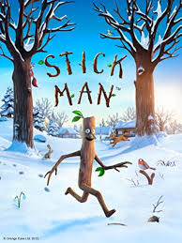
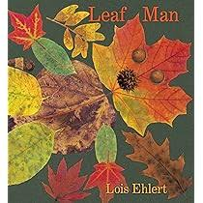
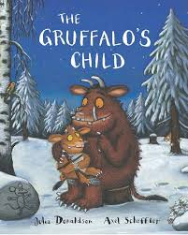
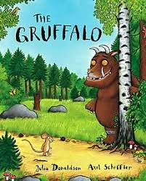
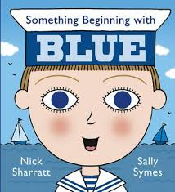
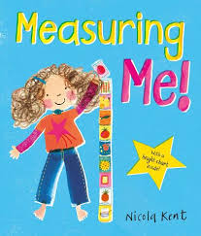
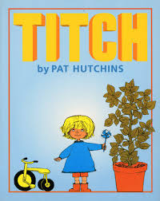
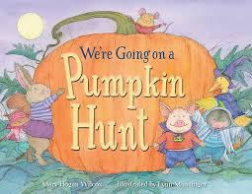
Communication, Language and Literacy | Mathematics
Pupils will be encouraged to develop their communication, indicating their wants and needs, listening and following instructions and maintaining their attention.  Pupils will learn a new phonic sound a week and will be encouraged to write and read / identify this sound in words.  Pupils will be encouraged to make marks and put meaning to these marks, as well as independently write their name. | Pupils will learn number songs to help them engage with numbers.  Pupils will be introduced to numbers to 10 (20) and understand the composition of these numbers (number bonds). Pupils will learn about more / less and early addition and subtraction.  Pupils will learn about mathematical concepts of size, weight and shape.

Here is an overview of what your child will be learning this term which we hope you will find useful. We would welcome any comments or questions you might have.

Launchpad - Autumn Term

Other Curriculum Areas
Physical Development- Pupils will develop their fine motor skills through threading, dough disco and mark making in a range of media. Pupils will engage in gross motor skills including ball skills, climbing and balancing and riding a tricycle.
Personal, Social & Emotional – Pupils will focus playing alongside others and beginning to share with others.
Understanding the World – Pupils will learn about themselves and label body parts, growing plants, Autumn and investigating objects.
Expressive Art and Design – Pupils will investigate their senses, learn about colours and participate in creating art using a range of media. Pupils will learn songs and use musical instruments.

Pupils will be introduced to the following stories over the term; Measuring Me, Something Beginning with Blue, Titch, We’re Going on a Pumpkin Hunt, Leaf Man, Gruffalo, Gruffalo’s Child, Stickman and Hurry Santa. All learning activities will be planned around these books.

Things to do at home:

- Read to your child to help develop their listening skills and love of stories.
- Practise your child’s phonic sounds
- Practise number recognition.
- Practise mark making and writing their name.



