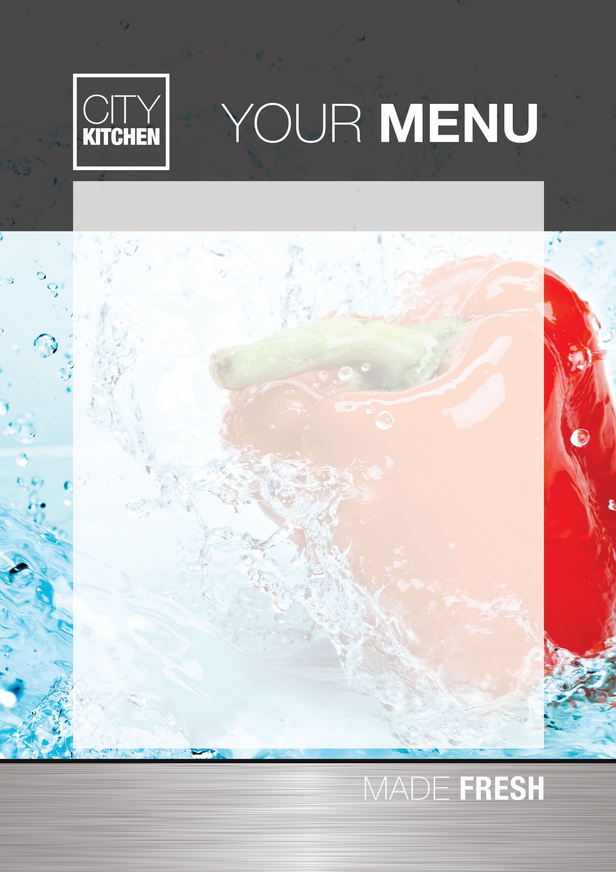
SANDWICHES/WRAP/JACKET POTATO OPTIONS
ALL SANDWICHES ARE MADE WITH WHITE BREAD, WHOLEMEAL BREAD OR
50/50 BEST OF BOTH BREAD

SANDWICHES
CHEESE SANDWICH TUNA SANDWICH
GLUTEN (WHEAT) MILK AND SOYA GLUTEN (WHEAT), EGG, MUSTARD,
FISH AND SOYA
HAM SANDWICH JAM SANDWICH
GLUTEN (WHEAT) AND SOYA GLUTEN (WHEAT) AND SOYA

WRAPS
CHEESE WRAP TUNA WRAP HAM WRAP
GLUTEN (WHEAT) MILK AND SOYA GLUTEN (WHEAT), EGG, MUSTARD, GLUTEN (WHEAT) AND
FISH AND SOYA SOYA

JACKET POTATOES
FLUFFY JACKET POTATOES WITH A SELECTION OF FILLINGS Inc.
CHEESE, BEANS, TUNA MAYO

THE DELI BAR WILL BE AVAILABLE DAILY WITH A SELECTION OF FRESH SALAD TO ACCOMPANY ALL OF THE ABOVE OPTIONS

