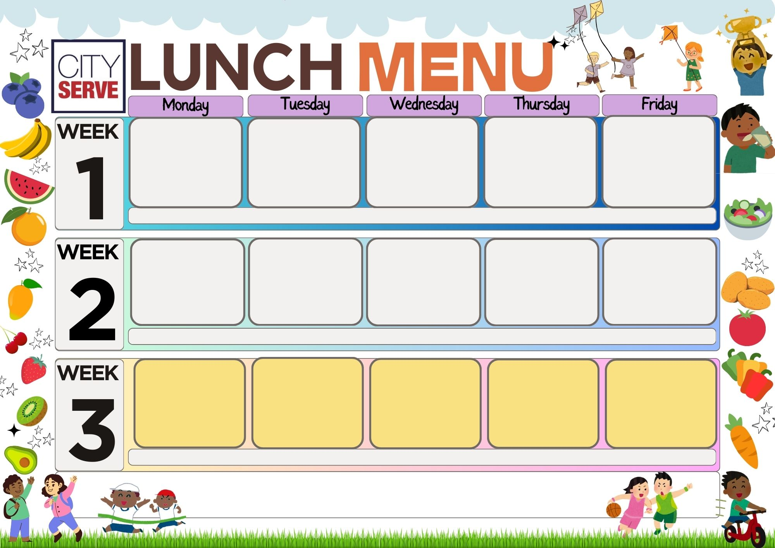
f
All Day Breakfast
All day vegetarian
breakfast (V)

Hash Brown
Garden Peas / Baked Beans

Chocolate Cracknel (V)
(VE) – VEGAN (V) – VEGETARIAN / Vegetarian Options Available Daily.
For any allergen or special dietary requirements, please speak to a member of the catering team.
Chicken Meatballs served with a Rustic Sauce
Cheese & Onion Pasty (V)
Potato Wedges / Pasta
Carrots / Green Beans

Fruit Crumble with Custard (V)
Cheese & Tomato Pizza (V)
Fish of the Day

Chunky Chips
Baked Beans / Sweetcorn

Ice Cream (V)

Pork Sausage
Quorn Sausage (VE)
Both served with Yorkshire Pudding & Gravy
Creamed Potato
Broccoli / Cauliflower

Moose (V)

Mild Chicken & Chickpea Curry served with Rice & Naan Bread
Vegetable Samosa (V)

Sweetcorn

Fruit Salad (V)
Cod Fish Cake
Italian Pasta Bake served
With Garlic Bread (V)
Chips
Baked Beans / Peas

Chocolate Crunch (V)
Cheese & Tomato Pizza (V)
Fish of the Day

Chunky Chips
Baked Beans / Peas

Ice Cream (V)

Lasagna served with
Garlic Bread
Veg Lasagna (V)

Rice / Sweetcorn

Shortbread (V)
Pork Hotdog
Quorn Hotdog (V)

Potato Balls
Garden Peas / Sweetcorn

Cookie (V)
Chicken Fillet
Quorn Roast (V)
With all the trimmings

Carrots / Broccoli

Jelly (V)
Roast Turkey
Quorn Roast (V)
With all the trimmings

Cauliflower & Broccoli

Moose (V)

Crispy Crumb Turkey Burger
Mac & Cheese (V)

Seasoned Potato Wedges
Baked Beans / Peas

Chocolate Muffin (V)
Beef Bolognaise
With Pasta Twists
Cheese & Potato Pie (V)
Green Beans / Sweetcorn
Garlic Bread

Flapjack (V)
Cheese & Tomato Pizza (V)
Cod Fish Cake

Chunky Chips
Baked Beans / Sweetcorn

Ice Cream (V)
Chilli
Vegetable Chilli (V)

Carrots
Green Beans

Cup Cake (V)

